**Cell Differentiation – Notes**

Blastocyst structure:

* Inner cell mass – around 30 cells that **make up the embryo**.
* One of the sources of **stem cells**.
* Trophoblast – Layer of cells surrounding the inner cell mass and blastocyst cavity that will **end up making the placenta**.

Stem cell characteristics:

* Are said to be **undifferentiated** – they aren’t specialised (yet) for any particular task.
* The stem cells from the inner cell mass end up differentiating into the 200 different types of adult cells.
* They can **proliferate** – **divide by mitosis** to make more stem cells **or differentiate**.
* They can **differentiate** into specialised cells given the right conditions.

Stem cell potency:

* Potency refers to the **extent at which a stem cell can differentiate** into a type of cell.
* The higher the potency the greater the **range of types** of cells the stem cell can specialise into.

Potency types:

* Totipotent (most potent) – Taken **from a zygote** and are capable of differentiating into **any cell type**, thus being useful if taking the cells didn’t kill the developing embryo.
* Any totipotent cell could be cultured to create a new human being because they haven’t differentiated (specialised) yet.
* Pluripotent – Taken from the **inner cell mass** of a 5-day old embryo.
* They can differentiate into **any cell type except for placental or support cells**.
* They aren’t as potent as totipotent stem cells from the zygote but more potent than any other stem cell.
* Multipotent (adult stem cells) – Taken from **adult tissue**.
* They can differentiate into the **type of cell** that **equates to the tissue they’re taken from** e.g., bone marrow stem cells can differentiate into any blood cell but not a skin or lung cell.
* Least potent of all the stem cells.

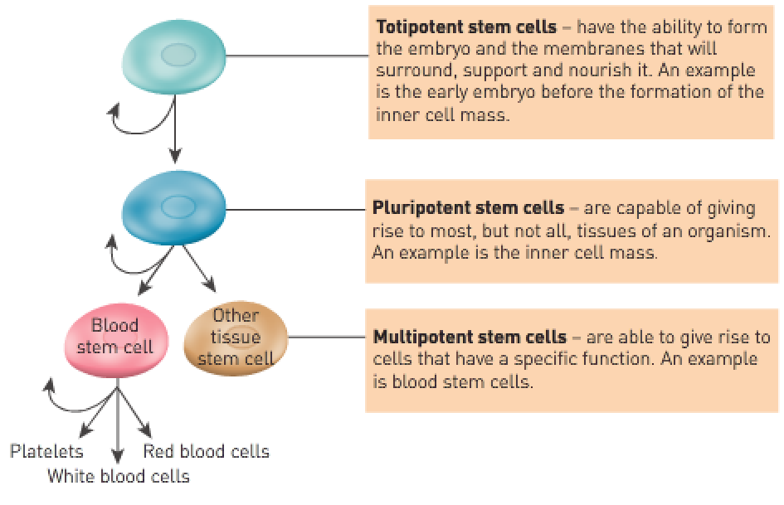

|  |  |
| --- | --- |
| Totipotent | Can give rise to **all the cell types** that make up the human body and all the cell types that make up the membranes that surround the developing embryo (including the placenta). |
| Pluripotent | Can give rise to all the cell types that make up the body but **not the cell types that make up the embryonic membranes or placenta**. |
| Multipotent | Can develop into more than one of the cell types that make up the body but **not all cell types**. |

Sources of cells:

* Cord blood:
* **Multipotent** stem cells can be extracted from the **umbilical cord or placenta** and **stored for later use**.
* These stem cells can differentiate into **any blood cell** and are useful for individuals who have **bone marrow or blood diseases**.
* There’s **no harm** to parent or baby when these cells are extracted.
* Embryonic stem cells:
* Cultured from frozen embryos obtained from IVF clinics.
* Unused embryos from IVF may be donated to research because the couple no longer desire additional children.
* Has significant ethical issues because obtaining them requires killing of an embryo.
* They come from embryos that aren’t derived from the patient’s own cells so the patient’s body may reject them.
* Adult stem cells:
* Multipotent adult stem cells can form cells of many kinds of tissue.
* A patient’s own cells could be used for treatment so the patient’s body won’t reject them.
* Not as potent as other types of stem cells.

Process of culturing stem cells:

1. Cells are **extracted from the inner cell mass** of the embryo (killing it).
2. The 30 cells are **harvested and cultured** in a dish.
3. Over a few days, the cells keep **multiplying** until the dish is full.
4. This subculturing can be **repeated** many times to provide a source of embryonic stem cells.
5. They can also be **frozen** for use in the future.
6. This can also be done with adult stem cells and cord blood.

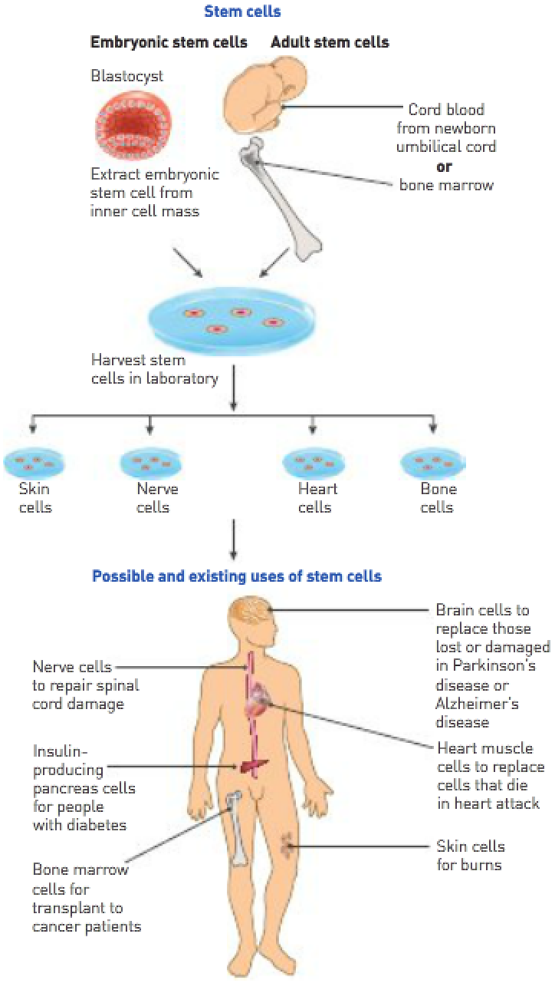

Therapeutic cloning:

* The **nucleus** from the body cell is **inserted into a donor’s egg**.
* The **donor’s egg has had its nucleus removed**.
* A **blastocyst** with **genetically identical information** to the **nucleus from which it came from** is produced.
* Any tissue developed from the stem cells could be transplanted into the patient **without the person’s immune system rejecting them**.
* Controversial because the embryo, if allowed to develop, would be an identical clone of the patient.

